Amazon Elastic File System (EFS) Documentation
Comprehensive Technical Summary & Architecture Guide

1. Executive Introduction to Amazon EFS
Amazon Elastic File System (Amazon EFS) is a fully managed, serverless, and highly scalable file storage service provided by AWS. It is designed to offer shared file access across thousands of compute instances simultaneously, without requiring any manual storage capacity provisioning or proactive performance tuning.
EFS natively grows and shrinks as files are added or deleted, handling storage scales dynamically up to multiple petabytes. This elasticity ensures applications experience continuous availability without capacity management overloads.
2. Architecture & Core Mechanics
Amazon EFS operates using the Network File System protocol versions 4 (NFSv4.0 and NFSv4.1), ensuring broad compatibility with legacy Linux applications, standard tools, and modern containers. It is a regional service, delivering out-of-the-box data durability and high availability by storing data synchronously across multiple Availability Zones (AZs).
EFS file system types
Amazon EFS offers Regional and One Zone file system types.
Regional – Regional file systems (recommended) store data redundantly across multiple geographically separated Availability Zones within the same AWS Region. Storing data across multiple Availability Zones provides continuous availability to the data, even when one or more Availability Zones in an AWS Region are unavailable.
One Zone – One Zone file systems store data within a single Availability Zone. Storing data in a single Availability Zone provides continuous availability to the data. In the unlikely case of the loss or damage to all or part of the Availability Zone, however, data that is stored in these types of file systems might be lost.
In the unlikely case of the loss or damage to all or part of an AWS Availability Zone, data in a One Zone storage class may be lost. For example, events like fire and water damage could result in data loss. Apart from these types of events, our One Zone storage classes use similar
Regional EFS file systems
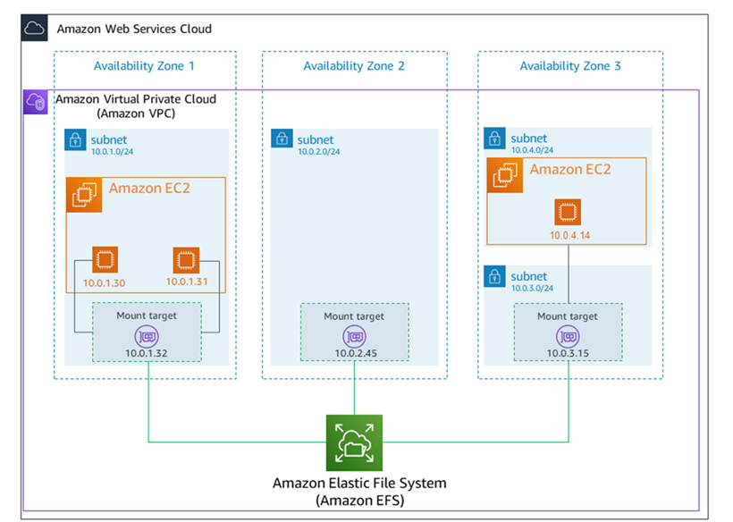

One Zone EFS file systems
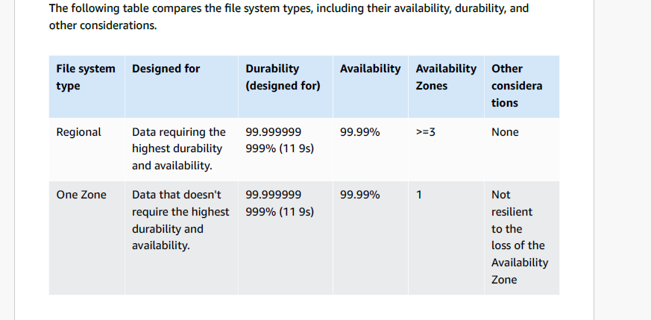
How Amazon EFS works with AWS Direct Connect and AWS Managed VPN
By using an Amazon EFS file system mounted on an on-premises server, you can migrate on-premises data into the AWS Cloud hosted in an Amazon EFS file system. You can also take advantage of bursting. In other words, you can move data from your on-premises servers into Amazon EFS and analyze it on a fleet of Amazon EC2 instances in your Amazon VPC. You can then store the results permanently in your file system or move the results back to your on-premises server.
Keep the following considerations in mind when using Amazon EFS with an on-premises server:
Your on-premises server must have a Linux-based operating system. We recommend Linux kernel version 4.0 or later.
For the sake of simplicity, we recommend mounting an Amazon EFS file system on an on-premises server using a mount target IP address instead of a DNS name.

3. Storage Classes & Smart Tiering
- EFS Standard: Optimized for active, frequently-accessed workloads requiring sub-millisecond read/write latencies.
- EFS Infrequent Access (IA): Cost-optimized tier designed for files accessed only a few times a quarter, dropping storage costs significantly.
- EFS Archive: Deep cold tier for long-term retention data accessed very rarely (a few times a year), providing the lowest cost per GB.
- Lifecycle Management: Automated movement rules that seamlessly shift files between Standard, IA, and Archive based on your age thresholds (e.g., transition to IA after 30 days of inactivity).
4. Performance & Throughput Options
4.1 Performance Modes
- General Purpose: The default mode, tailored for latency-sensitive applications like web hosting, content management systems (CMS), and microservices.
- Max I/O: Designed to scale to extreme parallelization, high throughput, and millions of IOPS, suitable for massive scale Big Data analytics.
4.2 Throughput Modes
- Elastic Throughput: The modern standard mode that automatically scales throughput capacity dynamically matching your application’s live operational traffic, charging you solely for what you use.
- Provisioned Throughput: Enables rigid dedication of bandwidth (allocated in MiBps) independent of the amount of total data stored in the filesystem.
- Bursting Throughput: Throughput scaling caps dynamically determined based on the total baseline volume size of your stored files.
5. Enterprise Integration, Security & Compliance
- Multi-Compute Support: Connects natively to Amazon EC2, Amazon ECS, Amazon EKS, AWS Lambda, and on-premises local hardware structures.
- Data Encryption: Enforces strict encryption at-rest (using AWS KMS managed keys) and encryption in-transit (using automated TLS 1.2 wrapper tunneling).
- POSIX Permissions: Fully respects granular standard Linux POSIX security configurations, user/group ownership masks, and root squashing flags via IAM Identity policies.
- Data Protection: Direct native backups executed seamlessly through AWS Backup alongside multi-region, cross-account real-time data replication.
- Task-7:
- Creating Shared File Storage for a Linux Web Application Using Amazon EFS
- Scenario Description:
- A company is deploying a Linux-based web application on multiple EC2 instances behind an Application Load Balancer. All instances must read and write user-uploaded files to a shared directory. In this task, you will use Amazon Elastic File System (Amazon EFS) to provide scalable, shared file storage that is accessible from multiple Availability Zones.
- Scenario Steps:
- 1- Create a Regional EFS File System
- 2- Configure Mount Targets and Security Groups
- 3- Launch Two Linux EC2 Instances in Different AZs
- 4- Mount the EFS File System on Both Instances
- 5- Verify Shared File Access Between Instances

1. Scenario Overview
A company is deploying a Linux-based web application on multiple EC2 instances behind an Application Load Balancer. All instances must read and write user-uploaded files to a shared directory. Amazon Elastic File System (EFS) provides the scalable, shared file storage needed, accessible from multiple Availability Zones simultaneously.

1.1 Architecture Diagram
The following table illustrates the high-level architecture:

Layer | Component
Load Balancing | Application Load Balancer (ALB)
Compute — AZ-1 | EC2 Linux Instance (us-east-1a)
Compute — AZ-2 | EC2 Linux Instance (us-east-1b)
NFS Endpoints | EFS Mount Targets (one per AZ)
Shared Storage | Amazon EFS Regional File System

Key Insight
EFS uses NFSv4.1 protocol — it mounts like any Linux directory. EC2 instances
have no awareness that the storage is remote; they interact with it exactly as a
local filesystem, enabling seamless shared access across all AZs.

2. Implementation Steps

Step 1 — Create a Regional EFS File System
Navigate to the AWS Console → EFS → Create File System. Select Regional as the file system type to ensure data is stored redundantly across multiple Availability Zones.

Setting | Value | Reason
File System Type | Regional | Stores data across 3+ AZs — automatic redundancy
Performance Mode | General Purpose | Best for web serving, CMS, file sharing workloads
Throughput Mode | Elastic | Auto-scales up/down with workload — no pre-provisioning
Encryption at Rest | Enabled | Data encrypted via AWS KMS — security best practice
VPC | Default VPC | Must match the VPC where EC2 instances reside

After Creation
Note the File System ID (e.g., fs-0abc1234). You will need it during the mount step.
EFS DNS format: fs-XXXXXXXX.efs.<region>.amazonaws.com

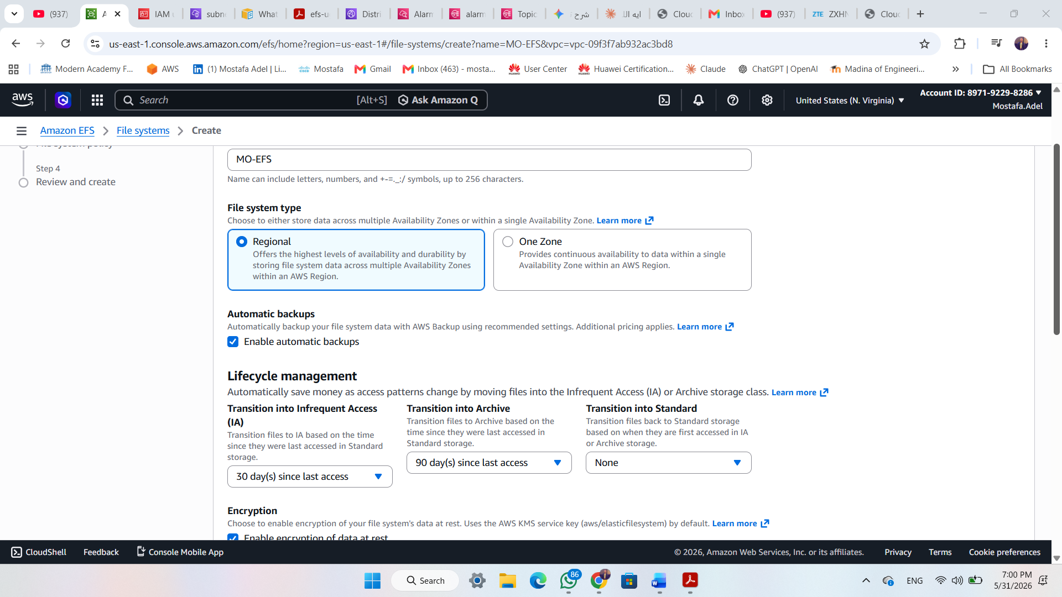

Step 2 — Configure Mount Targets and Security Groups
A Mount Target is the NFSv4 endpoint through which EC2 instances connect to the EFS file system. One Mount Target is created per Availability Zone. Access is controlled via Security Groups.

Security Group Configuration
Security Group | Rule Type | Protocol / Port | Source / Dest | Purpose
EFS-SG | Inbound | NFS — TCP 2049 | EC2-SG (source) | Allow EC2 → EFS NFS traffic
EC2-SG | Outbound | NFS — TCP 2049 | EFS-SG or 0.0.0.0/0 | Allow EC2 to reach Mount Target

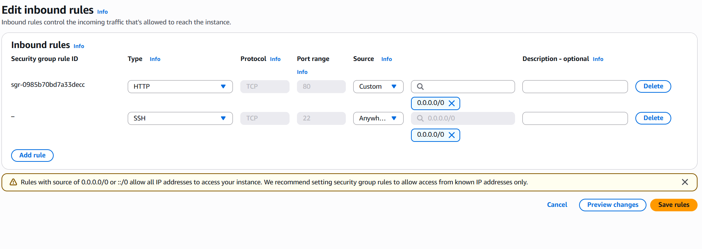

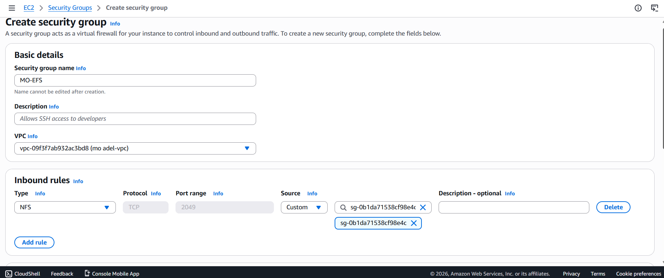
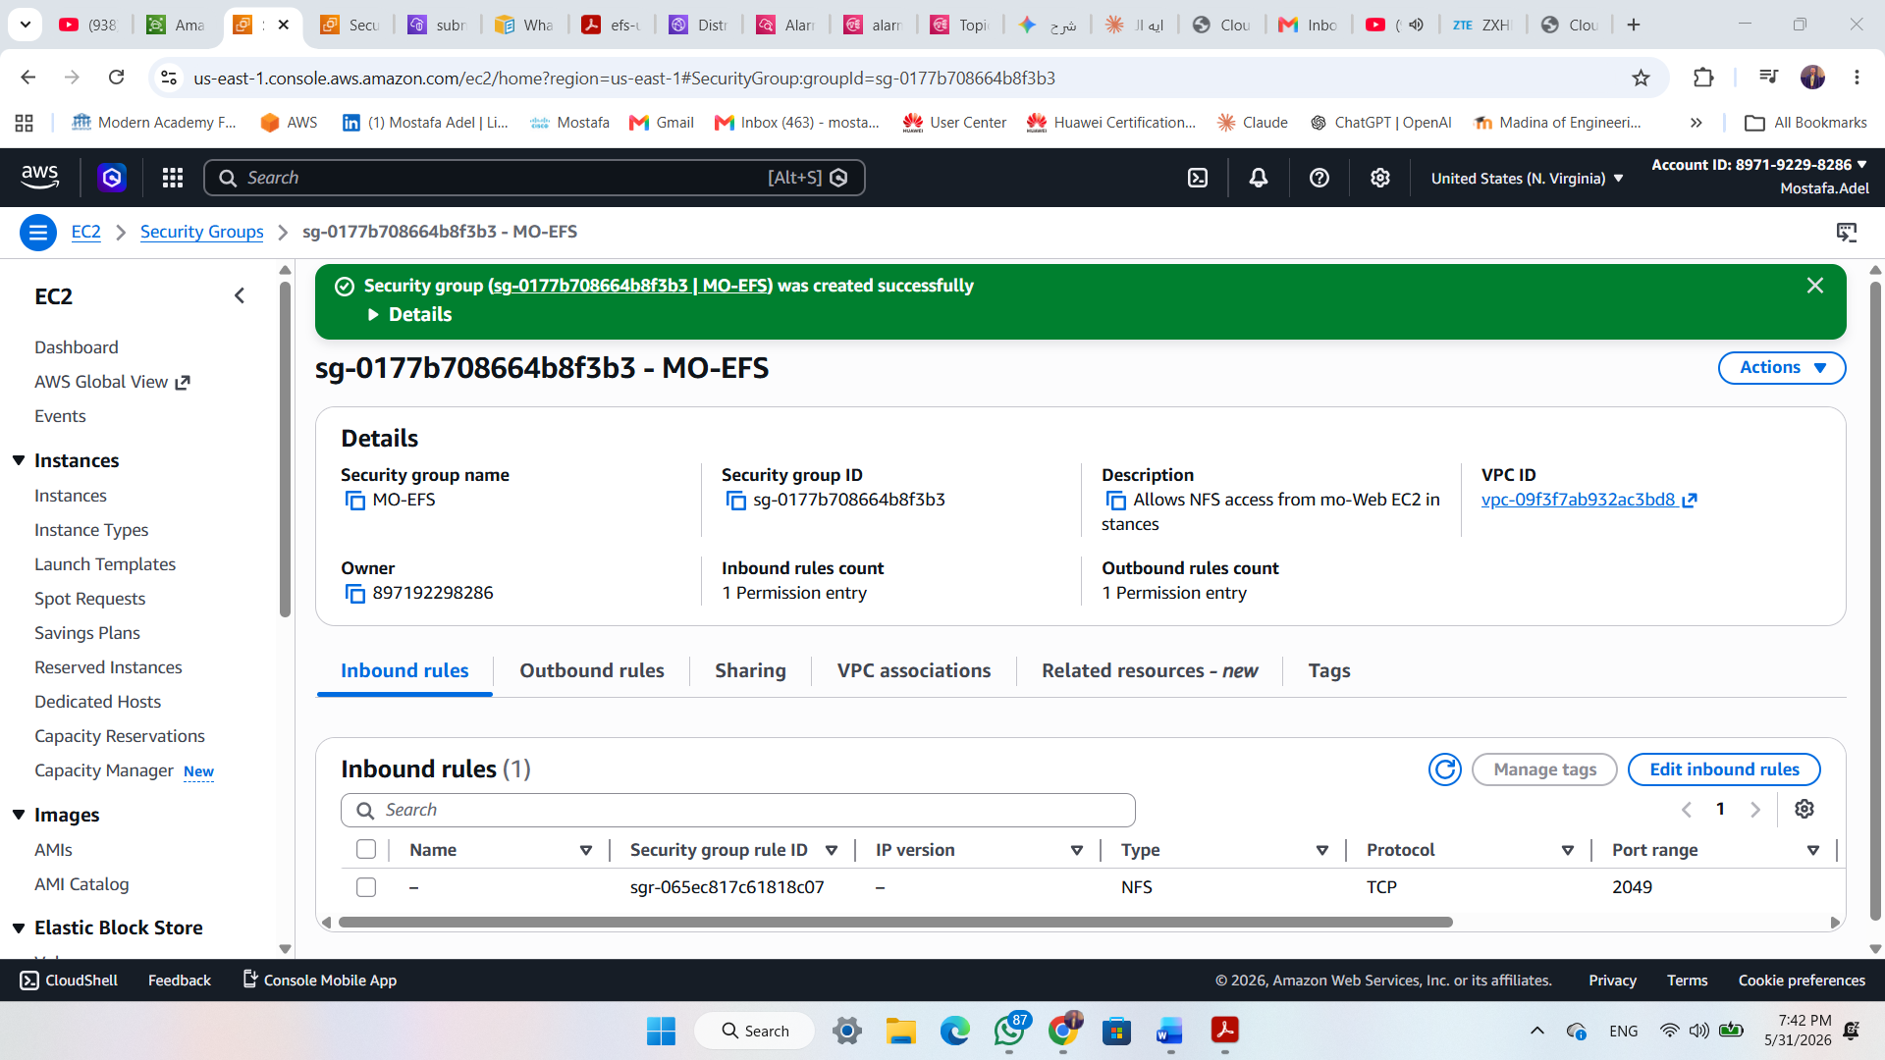

Step 3 — Launch Two Linux EC2 Instances in Different AZs
Two EC2 instances are launched in separate Availability Zones to demonstrate that EFS is truly shared across AZs. Both instances use the same AMI, key pair, and Security Group.

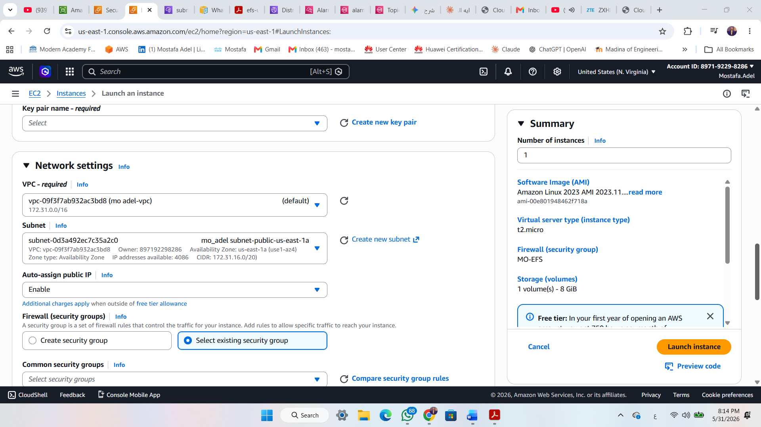

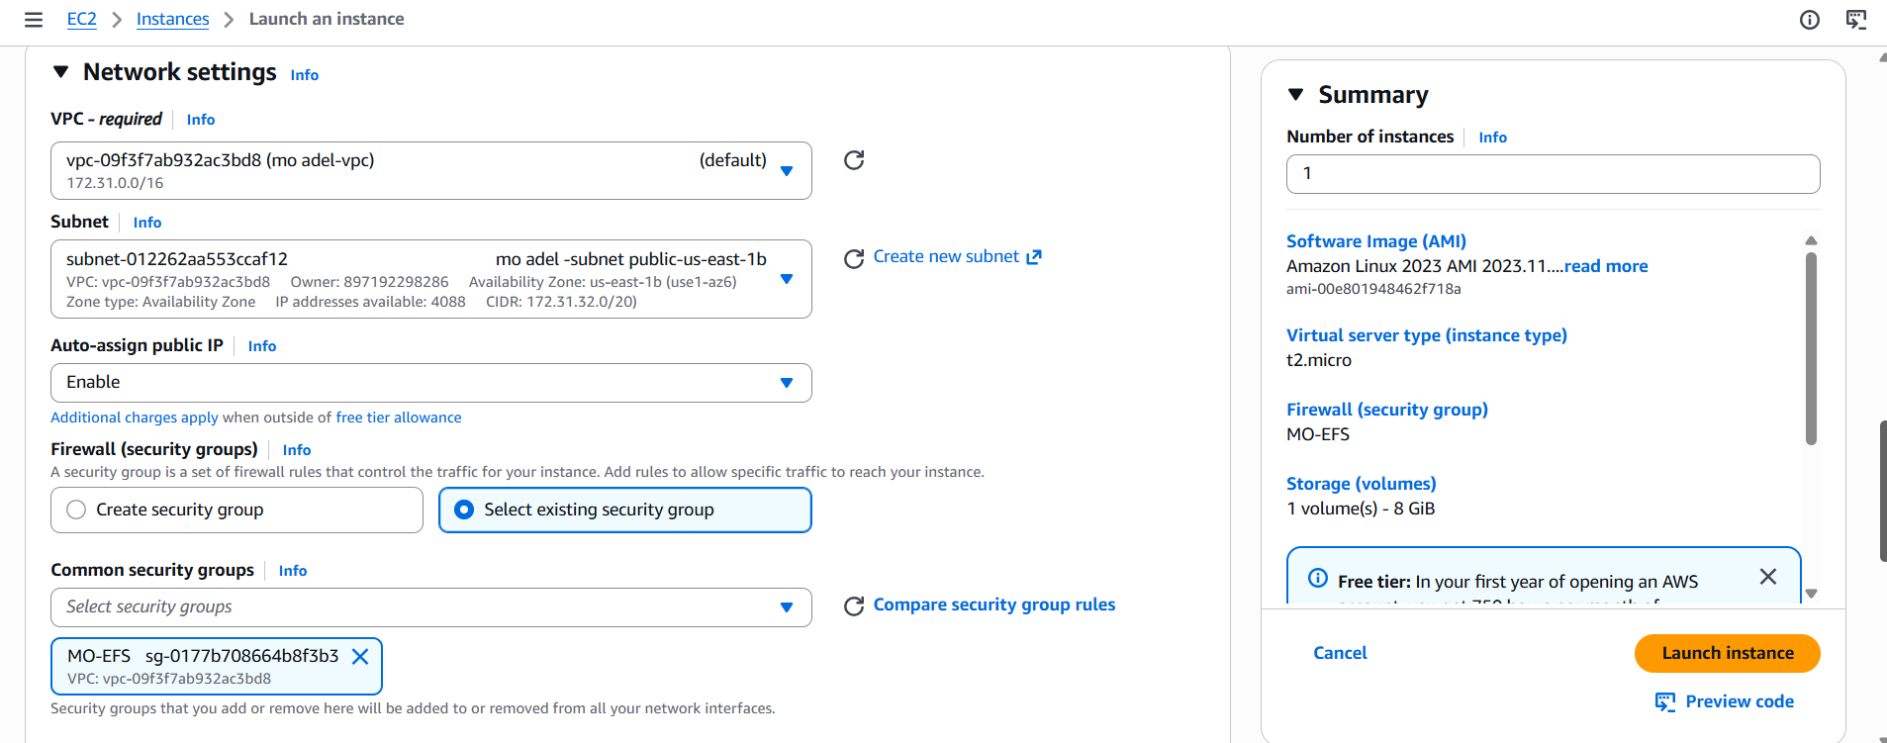

Step 4 — Mount the EFS File System on Both Instances
SSH into each EC2 instance and perform the following steps. Repeat on both instances.

Install the EFS Mount Helper
$ Amazon Linux 2023 / AL2
sudo dnf install -y amazon-efs-utils
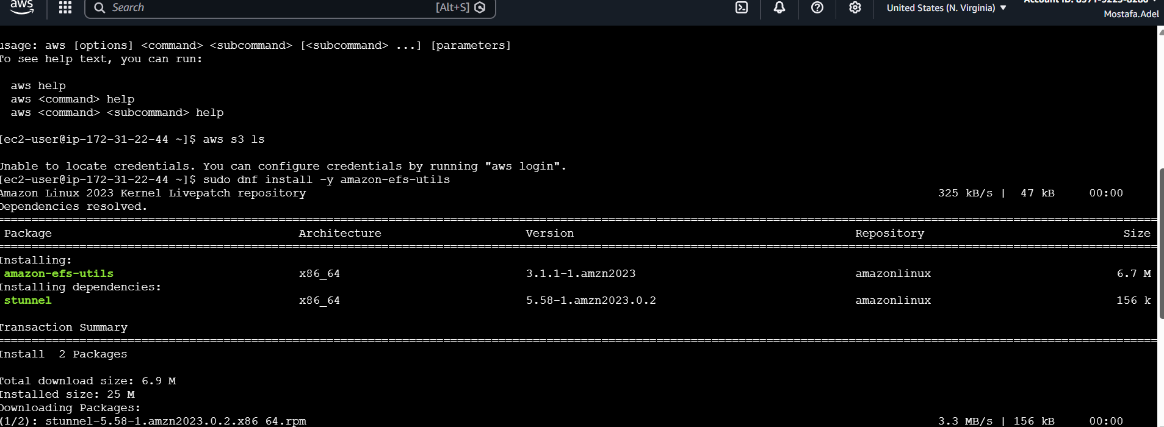

Create the Mount Directory
$ Create mount point
sudo mkdir -p /var/www/html/uploads

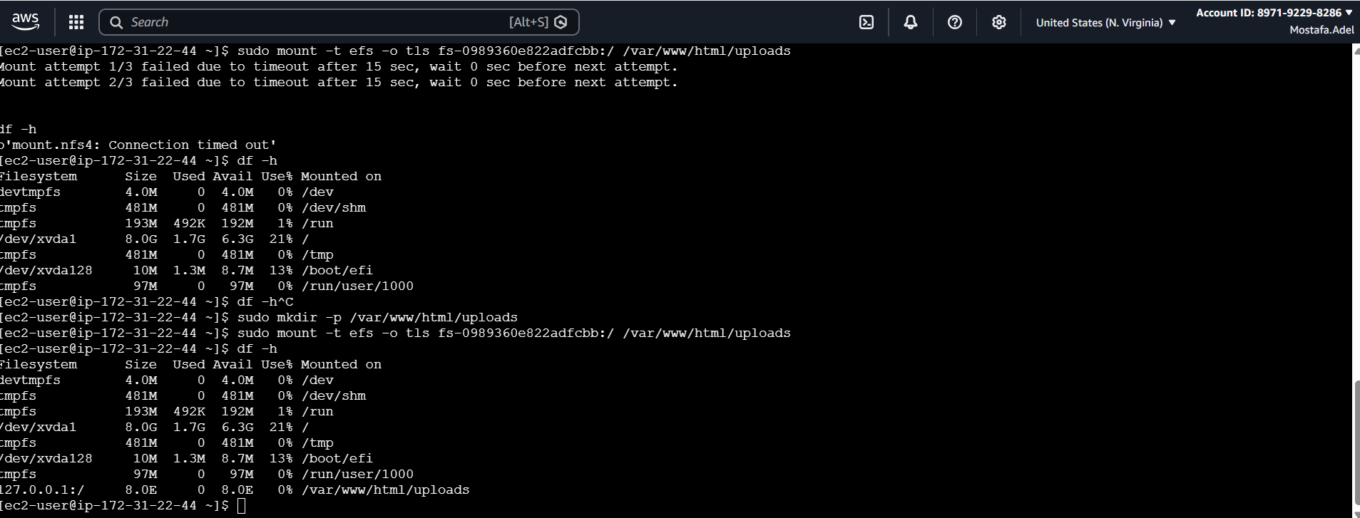

Mount the EFS File System
$ Mount using DNS name (recommended)
sudo mount -t efs -o tls fs-0989360e822adfccb:/ /var/www/html/uploads
# Alternative: using full DNS name
sudo mount -t efs -o tls \
fs-0abc1234.efs.us-east-1.amazonaws.com:/ /mnt/efs
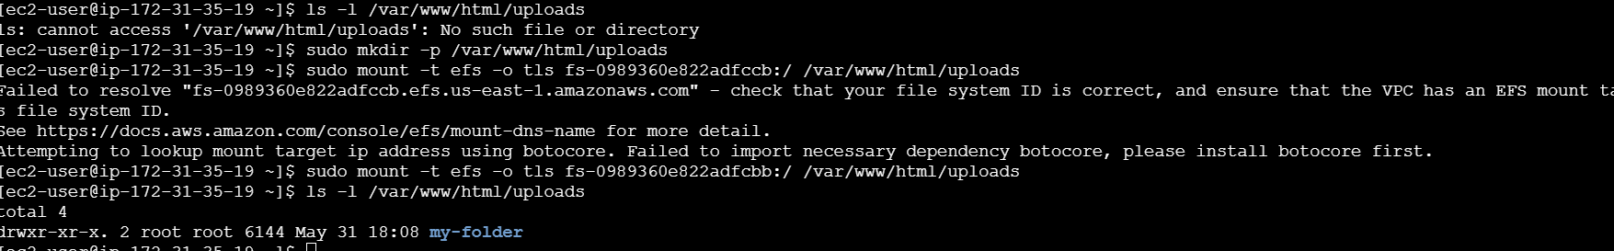

Step 5 — Verify Shared File Access Between Instances
Write a file from Instance 1 and confirm it is immediately readable from Instance 2, confirming real-time shared access across Availability Zones.

On Instance 1 (AZ-1a) — Write
$ Create test file
echo 'مسا مسا من السيرفر الاول' \
sudo mkdir -p /var/www/html/uploads/my-folder && echo "مسا مسا يا صاصا من السيرفر الأول" | sudo tee /var/www/html/uploads/my-folder/test.txt
sudo touch /var/www/html/uploads/test-sasa.txt
for test
echo "Hello from Server 01 👋" | sudo tee /var/www/html/uploads/test-sasa.txt

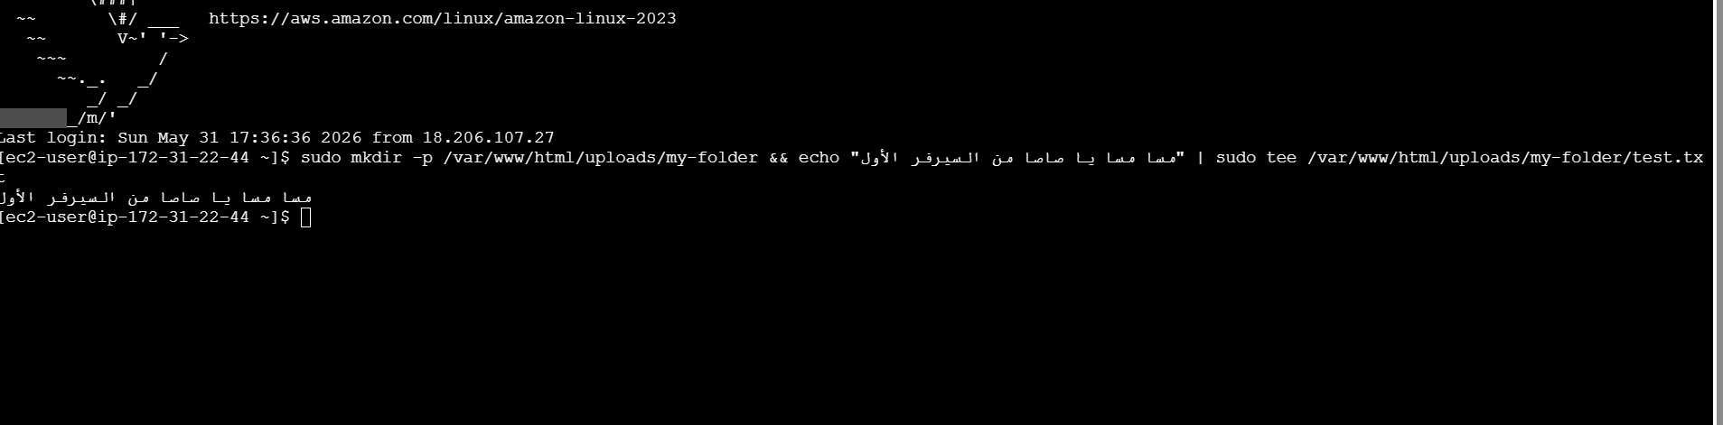

On Instance 2 (AZ-1b) — Read
$ Read same file
ls -l /var/www/html/uploads
cat /var/www/html/uploads/my-folder/test.txt
cat /var/www/html/uploads/test-sasa.txt

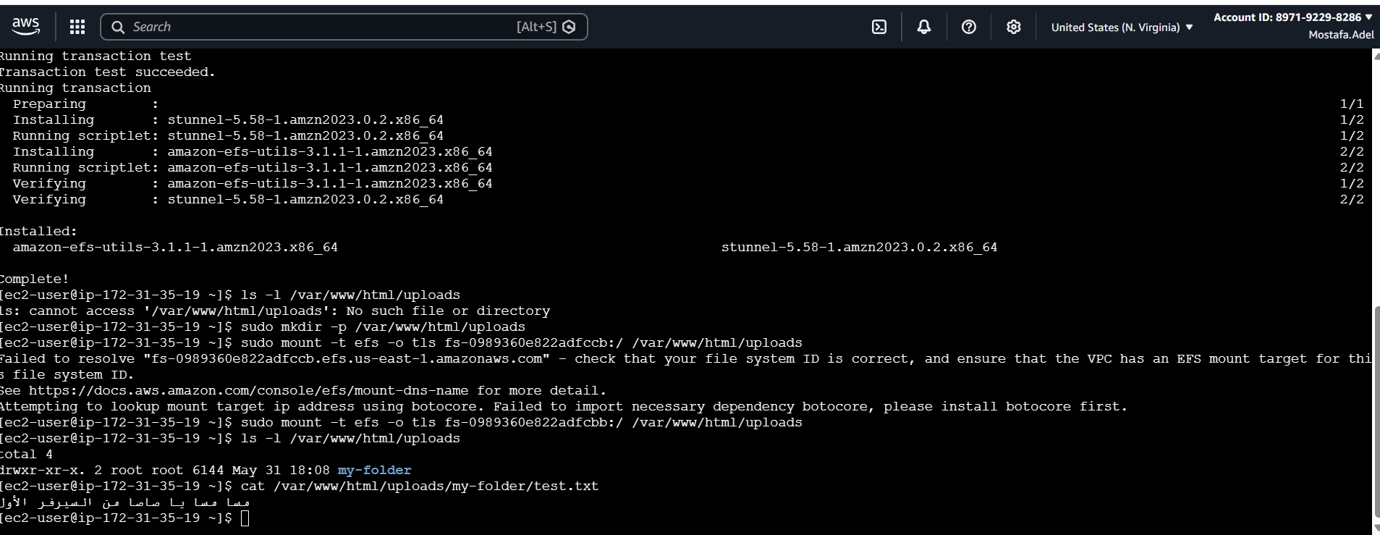

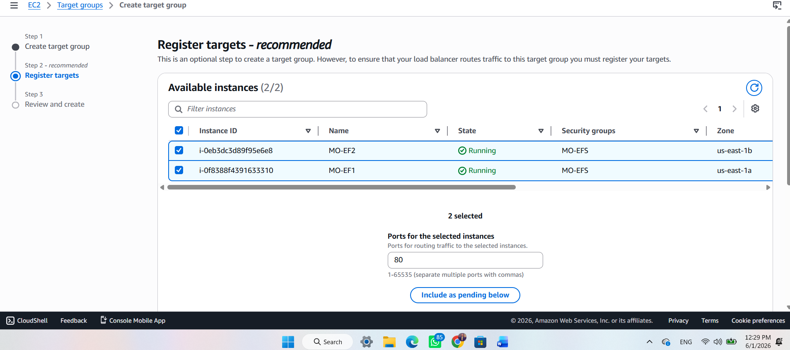

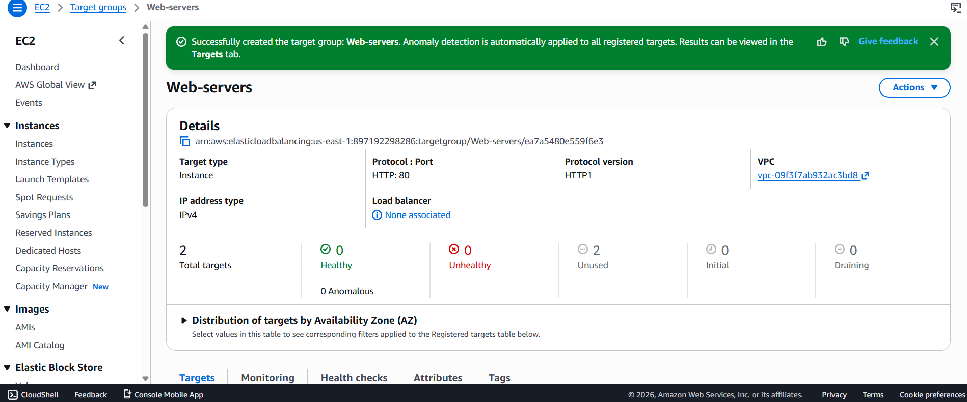
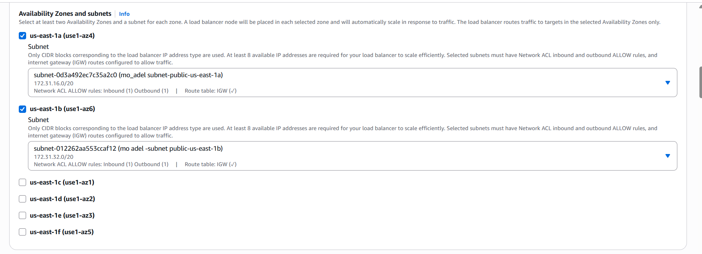
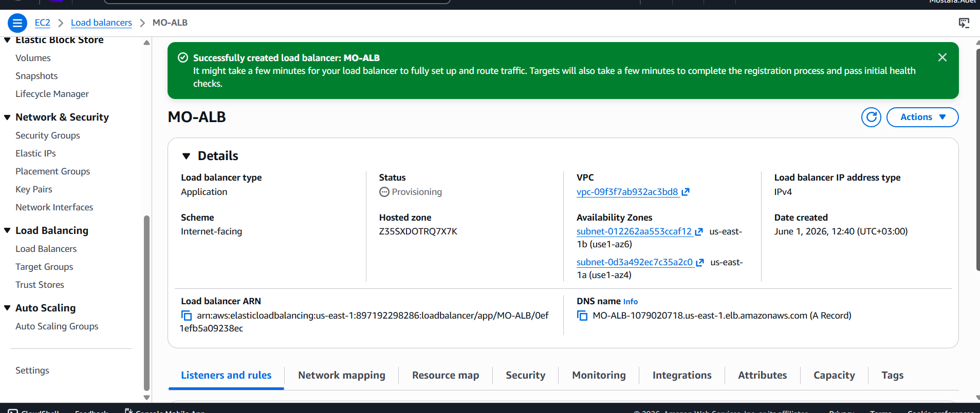
echo "<h1>Welcome to Server 01 🚀</h1>" | sudo tee /var/www/html/index.html
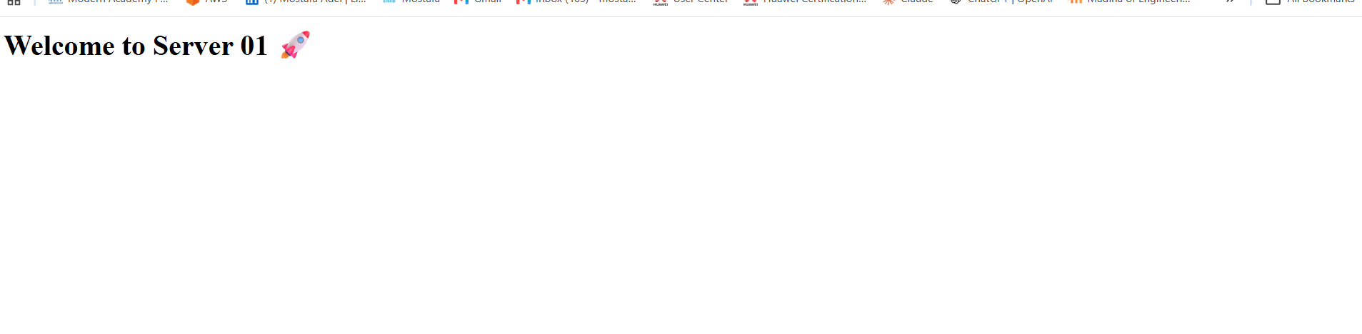
echo "<h1>Welcome to Server 02 🔥</h1>" | sudo tee /var/www/html/index.html
